**Inventory Management System for Medical Store**



**Major Project submitted towards partial**

**Fulfillment of the degree of Bachelor of Science**

**Year 2013**

Department of Computer Science and Engineering

**Guided By: Submitted By:**

Md. Jahangir Alam Sumon Kazi Afrin Jimi

Lecturer

Dept. of CSE Rezwan Ahmed

Dhaka City College

**Dhaka City College, Dhaka**

#### DISSERTATION APPROVAL SHEET

The dissertation entitled “**Inventory Management System for Medical Store”** submitted by Kazi Afrin Jimi and Rezwan Ahmed is approved as partial fulfillment of the degree of **Bachelor of Science** (Computer Science). Awarded by **National University, Bangladesh**.

Internal External

**Dhaka City College, Dhaka**

#### CERTIFICATE

This is to certify that **Kazi Afrin Jimi and Rezwan Ahmed** working in group have satisfactorily completed the project report on **“Inventory Management System for Medical Store**” towards the partial fulfillment of the degree of **Bachelor of Science** (Computer Science). Awarded by **National University,** Bangladesh for the academic year 2013.

**Project Guide Head of Department**

Md. Jahangir Alam Sumon Abdul Mannan Mandal

Internal External

**Dhaka City College, Dhaka**

**ACKNOWLEDGEMENT**

“We follow your foot-steps, we move on the path shown by you, we acknowledge you, and we are proud to have guides like you.”

We feel it our proud privilege to express our deep sense of gratitude and Indebtedness to **Md. Jahangir Alam Sumon** (Project Guide) for providing his painstaking and untiring supervision. We own our deep sense of gratitude and thanks for his constructive criticism, valuable suggestions and constant encouragement at all stages of development of this project report.

We wish to express our sincere thanks to all the faculty of Computer Science Department, for providing a conductive environment for proper development of project and the necessary facilities for completion of project.

We also express our sincere thanks and gratitude to **Md. Shahjahan Khan** (Principal) and **Md. Abdul Mannan Mandal** (Head of the Department) for their support and guidance and constant encouragement for completion of project report.

Kazi Afrin Jimi

Rezwan Ahmed

**INDEX**

**1) Introduction…………………………………………………………1**

1.1 Problem Definition and Proposed Solution 2

1.2 Project Decription 3

1.3 Need and Scope of Project 3

1.4 Definition, Acronyms and Abbreviation

1.5 Team Structure

**2) Literature Survey………………………………………………….12**

2.1Technology 13

2.2 Tools 13

**3) Process Model Adopted……………………………………………17**

3.1 Analysis 17

3.1.1 Requirement Analysis 17

3.1.2 Feasibility Analysis 17

3.1.3 Process Model Used 18

3.2 Design 19

3.2.1 Use case Diagram 19

3.2.2 Use case Specification 20

3.2.3 Activity Diagram 21

3.2.4 Class Diagram 22

3.2.5 Sequence Diagram 23

**4) Conclusion Remarks………………………………………………58**

4.1 Limitations of Project 59

4.2 Difficulties Encountered 59

4.3 Future Enhancement and suggestions 59

**5) References and Bibliography……………………………………...6**

**Chapter 1**

**Introduction**

* Problem Definition and Proposed Solution
* Project Description
* Need and Scope of Project
* Definition, Acronyms and Abbreviation
* Team Structure

**INTRODUCTION**

This project **“Inventory Management System for Medical Store”** is the combination of Inventory Management System for Medical Store and Medical Store Management System. By using Management System store owner can manage his store. This is designed to ease the work load of medical store professionals. The main feature includes invoicing, searching the medicines, maintaining stock of medical store and receive the orders of Customers.

The main idea to develop this software is to provide the facility of Inventory Management System for Medical Store where customer can buy required medicines without waiting. Other idea behind this software is to provide the facility to automate and manage daily activities of store like billing, medicine information, stock details and more. In present trend this application is used in every medical stores. This system will save time and increase work efficiency.

This software helps to track number of customers and who buy medicine. Flexible and adaptive software suited to medical stores or pharmacies of any size.

* 1. **Problem Definition and Proposed Solution**
* Currently we have to go to the Medical Store to buy medicines sometime which is not convenient to us. If medical store is not near then we have to travel to some distance to buy medicines.
* So we require a facility to buy medicine from our home and also that should be delivered very soon.
* At present Medical Stores maintain their day to day transactions manually which is very tough task.
* These have shops thousands of products they need to track of all these products to check the stock, expiry date etc.
* A proper system is required to maintain all these information.
* Medical professionals need a full pledged software to maintain their day to day transactions, daily sales report etc.
* It is the complete medical shop management software is so designed as to ease the work load of medical shop professionals. The main feature includes invoicing, inventory and stock control, accounting.

* This software helps you to track all the profits, loss, profitable clients and products of medical store moreover it’s a medical store accounting software.
* This System will store the information of medicines & customers in the system. It will also store the information about stock details. This system provides security by granting accessrights for changing the sensitive data to administrator only. Customized search options are also available in this system.

**Proposed Solution**

Generally, peoples have to go to the medical store for purchasing medicines. And medical store keeper manage the store manually. To overcome both the problems we want do develop a system which would provide the facility of Inventory Management System for Medical Store , by which customer can order the medicine online, and system can also be used as medical store management tool.

* 1. **Project Description**
* The main objective of this software is to reduce the work load of medical shop professionals and to provide facility of online purchase of Medicines.
* To automate the existing system of manually maintain the record of sales, purchases, suppliers and customers and other transactions made at the counter.
* The record of all transactions, customers and salesman can be maintained for future reference .
* To search a Particular medicine either by name of medicine or by name of manufacturer.
* To delete any medicine which is not useful or out of stock.
* To generate bill of sold medicines.
* To manage medical store properly and to save time.
  1. **Need and Scope of Project**

**Identification of need**

Inventory Management System for Medical Store is software which is very helpful for Local medical Store as well as for Big dealer.

Medical Store Management System deals with all kind of medicines details, customer details, dealer details, stock details, expiry detail, order details, location details, billing and purchasing related details too. It tracks all the details of a medicines with price and expiry date.

It is needed for following:

* Handling inquiries from prospective customer.
* Handling the location of medicines in shop.
* Maintain the medicines information .
* Maintain the customer details.
* Parts and dealer’s details.
* Order details.
* Maintain stock details.
* Billing and purchasing.

**Scope of Project**

The different areas where we can use this application are :

* This software can be used by a wide variety of outlets (Retailers and Wholesalers).
* To automate the process of manually maintaining the records related to the subject of maintaining the stock and cash flows.
* This software reduces the human effort and time saving.
* This can be used at every Medical shop because it is very easy to use and operate as it is very user friendly.
* It can be used in hospitals and modifications can be easily done according to requirements.
* Any hospital can make use of it for providing information about

medicines and price of medicines.

* 1. **Definition, Acronym and Abbreviation**

**Store Owner:**

Store Owner is the person who will use this software to take online order and who manages the Medical Store.

**Customer:**

Customer is the person who buy medicine online as well as to go to store.

* 1. **Team Structure**

Structure of our team is Democratic Decentralized (DD). Our team has no permanent leader. Rather we have task coordinators. Decisions on problems and approach are made by group consensus. Communication among team members is horizontal.

**Structure of Team:**

**Md. Jahangir Alam Sumon (Project Guide)**

**Players**

**Rezwan Ahmed**

**Kazi Afrin Jimi**

**Advantage :**

The length of time team live together affects team morale. It has been found that DD team structure result in high morale and job satisfaction and is therefore good for teams that will be together for a long time.

**Disadvantage :**

The DD team structure is best applied to problems with relatively low modularity, because of the higher volume of communication needed.

**Chapter 2**

**Literature Survey**

* Technology Used
* Tools Used

**LITERATURE SURVEY**

**2.1 Technology Used**

The project requires the following software tools in order to function properly:

**Programming Language:** JAVA is used as a programming language in this software project.

Java is a general-purpose, class-based, object-oriented computer programming language that is specifically designed to have as few implementation dependencies as possible. It is intended to let application developers "write once, run anywhere" (WORA), meaning that code that runs on one platform does not need to be recompiled to run on another. Java applications are typically compiled to bytecode (class file) that can run on any Java virtual machine (JVM) regardless of computer architecture. Java is one of the most popular programming languages in use, particularly for client-server web applications. Java was originally developed by James Gosling at Sun Microsystems (which has since merged into Oracle Corporation) and released in 1995 as a core component of Sun Microsystems' Java platform.

**Principles:**

There were five primary goals in the creation of the Java language:

* It should be "simple, object-oriented and familiar"
* It should be "robust and secure"
* It should be "architecture-neutral and portable"
* It should execute with "high performance"
* It should be "interpreted, threaded, and dynamic"

**Web Technology:** For Web Technology we uses HTML and we also applied CSS for good GUI.

**Front End:** In this project Java is used as Front End. This is used as coding language.

**Back End:** In this project MYSQL is used as Back End. This is used to store database of the project.

MySQL is (as of 2008) the world's most widely usedopen source relational database management system (RDBMS) that runs as a server providing multi-user access to a number of databases. It is named The SQL phrase stands for Structured Query Language. It is also a popular choice of database for use in web applications.

**Web Server:** Apache Tomcat and Glass Fish is servers used as local host.

**2.2 Tools Used**

The project requires the following software tools in order to function properly:

* **JDK1.5**: For Graphical User Interface i.e Form designing and connectivity to the database.
* **NETBEANS 6.0**: Net Beans IDE 6.0 provides support for the Java specification, which makes programming enterprise applications and web services much simpler.
* For storage use **My SQL** database software.
* **Enterprise Architect** & **Smart draw** are used to create or draw Various types of Diagrams and Models

**Hardwar Tools Used:**

|  |  |
| --- | --- |
| **Operating System** | Windows |
| **Processor** | Pentium-III |
| **Ram** | 256 MB Ram |
| **Memory** | 512 KB Cache Memory |
| **Hard disk** | 10 GB |
| **Key Board** | Microsoft Compatible 101 or more Key Board |

**Chapter 3**

**Process Model Adopted**

* Analysis
* Design

**PROCESS MODEL ADOPTED**

**3.1 Analysis**

**3.1.1 Requirement Analysis**

Requirements are a feature of a system or description of something that the system is capable of doing in order to fulfill the system’s purpose. It provides the appropriate mechanism for understanding what the customer wants, analyzing the needs assessing feasibility, negotiating a reasonable solution, specifying the solution unambiguously, validating the specification and managing the requirements as they are translated into an operational system.

**Software:**

|  |  |
| --- | --- |
| * **Operating System:** |  |
|  | **Windows XP and newer versions.** |
| * **Front End :** |  |
|  | **Microsoft Visual Studio 2008** |
| * **Back End:** |  |
|  | **Microsoft SQL Server 2005** |
|  |  |

**Functional Requirement:**

The functional requirements describe the interaction between the system and its environment. For our project functional requirements may be stated as follows –

The project requires the following software in order to function properly:

* **Visual Studio**: For Graphical User Interface i.e Form designing and connectivity to the database.
* For storage use **My SQL** database software.

**Non-functional requirements:**

The non-functional requirement describes a restriction on the system that limits our choice for developing a solution to problem. The non-functional requirements in our project are –

* **Time:** The project should be completed within the stipulated time period.
* **Cost:** The cost involved in making the project should be feasible. The automated system ought to be less expensive than the manually handled system.

**3.1.2 Feasibility Analysis**

A feasibility study refers to the implementation of the project. “Can the project be implemented?” if yes, then what technology we should, are we capable of using that technology, can that technology meet the system specification etc.

Feasibility is the study of impact, which happens in the organization by the development of a system. The impact can be either positive or negative. When the positives nominate the negatives, then the system is considered feasible.

Three key factors are to be considered during the feasibility study:

1. **Technical Feasibility**

Evaluating the technical feasibility is the trickiest part of a feasibility study. This is because, at this point in time, not too many detailed design of the system, making it difficult to access issues like performance, costs on (on account of the kind of technology to be deployed) etc. a number of issues have to be considered while doing a technical analysis. The main consideration is to be given to the study of available resources of the organization where the software is to be implemented. Here the system analyst evaluates the technical merits of the system giving emphasis on the performance, Reliability, maintainability and productivity.  
We can strongly say that it is technically feasible, since there will not be much difficulty in getting required resources for the development and maintaining the system as well. All the resources needed for the development of the system as well as the maintenance of the same is available in the organization here we are utilizing the resources which are available already.

1. [**Economic**](http://www.blurtit.com/q117820.html)**Feasibility**

Development of this application is highly economically feasible .The organization needed not spend much m money for the development of the system already available. The only thing is to be done is making an environment for the development with an effective supervision. If we are doing so, we can attain the maximum usability of the corresponding resources. Even after the development, the organization will not be in a condition to invest more in the organization .Therefore, the system is economically feasible.

1. **Operational Feasibility**

Proposed projects are beneficial only if they can be turned into information systems that will meet the organizations operating requirements. Simply stated, this test of feasibility asks if the system will work when it is developed and installed. Are there major barriers to Implementation? Here are questions that will help test the operational feasibility of a project:

Operational feasibility determines how much effort will be required in selling the proposed system, and make it easily adoptable for the user. Since no such system exists which is a freeware or performing so many tasks together and spying client machine is essential these days in many areas and hence the system is behaviorally feasible. Feasibility study of proposed system gave a satisfactory conclusion.

Our Feasibility analysis of this system involves 6 steps:-

* Form a project team
* Enumerate potential candidate system.
* Determine and evaluate performance and cost effectiveness of system.
* Weight system performance and cost data.
* Select the best system.
* Prepare and report final directive to the manager.

**3.1.3 Process Model Used**

To solve the actual problem in an industry setting software engineer or a team must incorporate a development strategy that encompasses the process, method, tools and layer of generic phases. This strategy is often called as software process model.

The factors for deciding the process model includes:

* Nature of software
* Application
* Tools and Methods used
* Deliverables

Our project follows the **waterfall model/ Linear Sequential Model.** The linear sequential model also called as classic life cycle or the **waterfall model** is a [sequential](http://en.wikipedia.org/wiki/Sequence) [software development model](http://en.wikipedia.org/wiki/Software_development_model) (a process for the creation of software) in which development is seen as flowing steadily downwards (like a [waterfall](http://en.wikipedia.org/wiki/Waterfall)) through the phases of [requirements analysis](http://en.wikipedia.org/wiki/Requirements_analysis), [design](http://en.wikipedia.org/wiki/Software_design), [implementation](http://en.wikipedia.org/wiki/Implementation), [testing](http://en.wikipedia.org/wiki/Software_testing) , [integration](http://en.wikipedia.org/wiki/Enterprise_application_integration), and [maintenance](http://en.wikipedia.org/wiki/Software_maintenance).

The linear sequential model suggests a systematic, sequential approach to software development that begins at the system level and progresses through analysis, design,coding, testing, and support. Modeled after a conventional engineering cycle, the linear sequential model encompasses the following activities:

**The steps of waterfall model are:**

* Requirement Definition
* System and Software Design
* Implementation
* Integration and System Testing
* Operation and Maintenance.

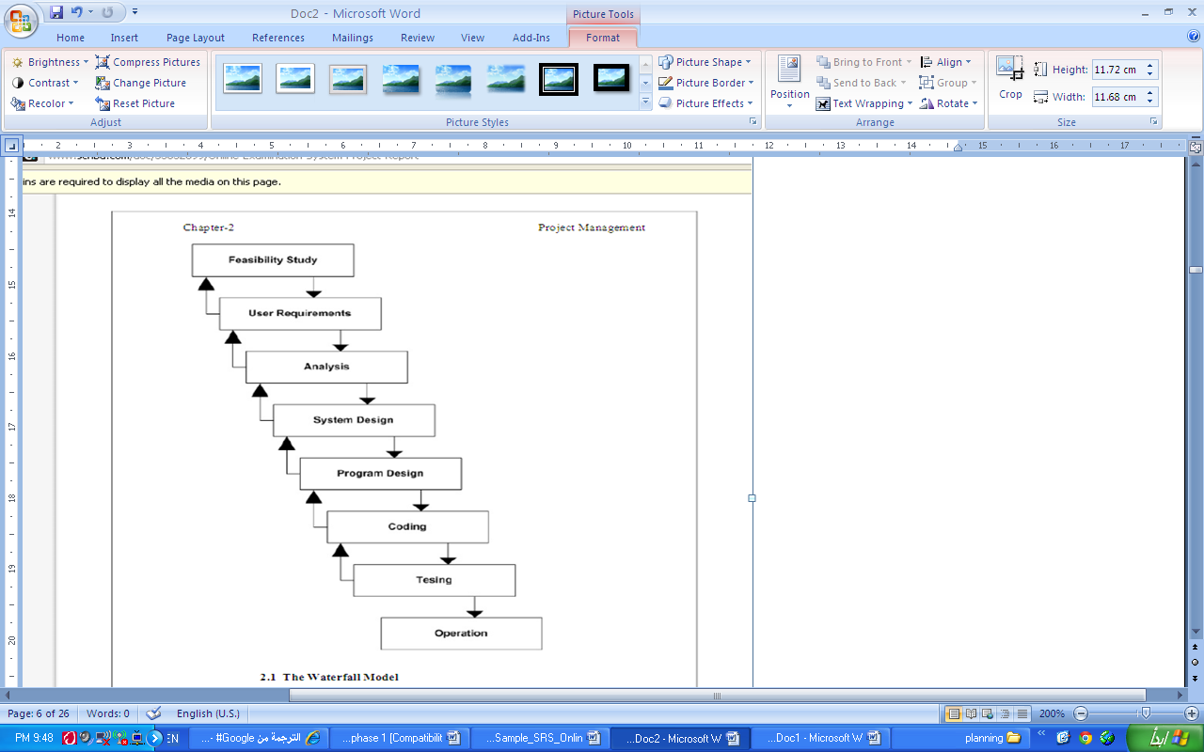

**WATERFALL MODEL**

**Advantages and Disadvantages**

**Advantages of Waterfall Model**

1. Waterfall model is simple to implement and also the amount of resources required for it are minimal.
2. In this model, output is generated after each stage (as seen before), therefore it has high visibility. The client and project manager gets a feel that there is considerable progress. Here it is important to note that in any project psychological factors also play an important role.
3. Project management, both at internal level and client’s level, is easy again because of visible outputs after each phase. Deadlines can be set for the completion of each phase and evaluation can be done from time to time, to check if project is going as per milestones.
4. This methodology is significantly better than the haphazard approach to develop software. It provides a template into which methods of analysis, design, coding, testing and maintenance can be placed.
5. This methodology is preferred in projects where quality is more important as compared to schedule or cost.

**Disadvantages of Waterfall Model**

1. Real projects rarely follow the sequential flow and iterations in this model are handled indirectly. These changes can cause confusion as the project proceeds.
2. It is often difficult to get customer requirements explicitly. Thus specifications can’t be freezed.
3. In this model we freeze software and hardware. But as technology changes at a rapid pace, such freezing is not advisable especially in long-term projects.
4. This method is especially bad in case client is not IT-literate as getting specifications from such a person is tough.
5. Even a small change in any previous stage can cause big problem for subsequent phases as all phases are dependent on each-other.
6. Going back a phase or two can be a costly affair.

**6.1.3 Reasons for use**

1. It is simple to implement and also the amount of resources required for it are minimal.
2. It is significantly better than the haphazard approach to develop software.
3. It provides a template into which methods of analysis, design, coding, testing and maintenance can be placed.
4. It is preferred in projects where quality is more important as compared to schedule or cost.

**3.2 Design**

**3.2.1 Use Case Diagram**

Actor: Administrator (Medical owner)

Actor: User

**Main Use case:**



**Fig:** Use case diagram for Medical Store Management System.

**Medical Store owner Use case:**



**Fig:** Use case diagram for Medical Store Owner

**Medical Store owner Dealing With Customer :**



.

**Fig:** Use case diagram for Customer

**Use case Specification:**

Actors at system level:

1. Medical Store Owner
2. Customer

Use case at system level:

1. Addition, Deletion and searching of particular information.
2. Generation of bill.
3. View tranctions.

**Main Diagram**

**Brief Description**

This use case will be directed when the user log on the system. It provides following choices according to the user:

If the user is owner, it provides owner with only one choices :-

* Dealing with Customer*

Customer information (name,age,gender,)

The user chooses one of the choices and the required action is

performed.

* If the user is owner, it provides admin with the choice of add, delete or update Medicine information as well as can also search medicines .

**Precondition**

Owner should be registered as authorized user.

**Postcondition**

Owner should log out after the transaction.

**Main Flow: M1**

|  |  |  |  |  |
| --- | --- | --- | --- | --- |
| Step | Actor | Description | Condition | Location |
| 1. | Owner | System prompts the Administrator to select the desired activity. | ------------ | ---------- |
| 2. | Owner | If the activity selected is **Add Medicine**, the flow is directed to subsystem level mainflow **.** | Addition ofMedicine | M-2 |
| 3 | Owner | If the activity selected is **Search Medicine**, the flow is directed to subsystem level mainflow. | Searcting ofMedicine | M-3 |
| 4 | Customer | Customer Provide the Required information | ------------ | ---------- |
| 5 | Customer | Pay the amount for the medicine | Payment forMedicine | M-4 |

**Name:**

**Medical Store Owner**

Actor: Owner

**Brief Description**

This use case will be directed when the user selects Add medicine, delete medicine, search medicine and update medicine in main flow M-1 .

Here admin can add, delete, update medicine information.

**Sub flow S-1.1**

|  |  |  |  |  |
| --- | --- | --- | --- | --- |
| Step | Actor | Description | Condition | Location |
| 1 | Owner | Add,Delete, Update medicine | --------- | ----------- |
| 2 | Owner | Search medicine | Searching | ----------- |
| 3 | Owner | Owner wants to view transaction detail | --------- | ----------- |

**Dealing With Customer**

Actor: Owner

**Brief Description**

This use case will be directed when Owner Deals with Customerin main flow M-1

In this owner perfom following task:-

1. Take order

2. Check availability

3. Provide Medicine

4. Generate Bill

5. Receive Amount

**Sub flow S-1.2**

|  |  |  |  |  |
| --- | --- | --- | --- | --- |
| Step | Actor | Description | Condition | Location |
| 1 | Owner | System prompts the Owner to take order. | --------- | ----------- |
| 2 | Owner | Here owner check the availability and provide the reqired medicine | Search medicine | S-1.1 |
| 3 | Owner | Here Owner Generae the bill for the medicine | Generate bill | S-1.1 |
| 3 | Owner | Here Owner receive amount for the medicine | Receive amount | S-1.1 |

**3.2.3.State Diagram**

**For Registration**



**Fig:** State Diagram for registration of Admin.

**For Login**



**Fig:** State Diagram for Login of Admin.

**3.2.4 Activity Diagram**

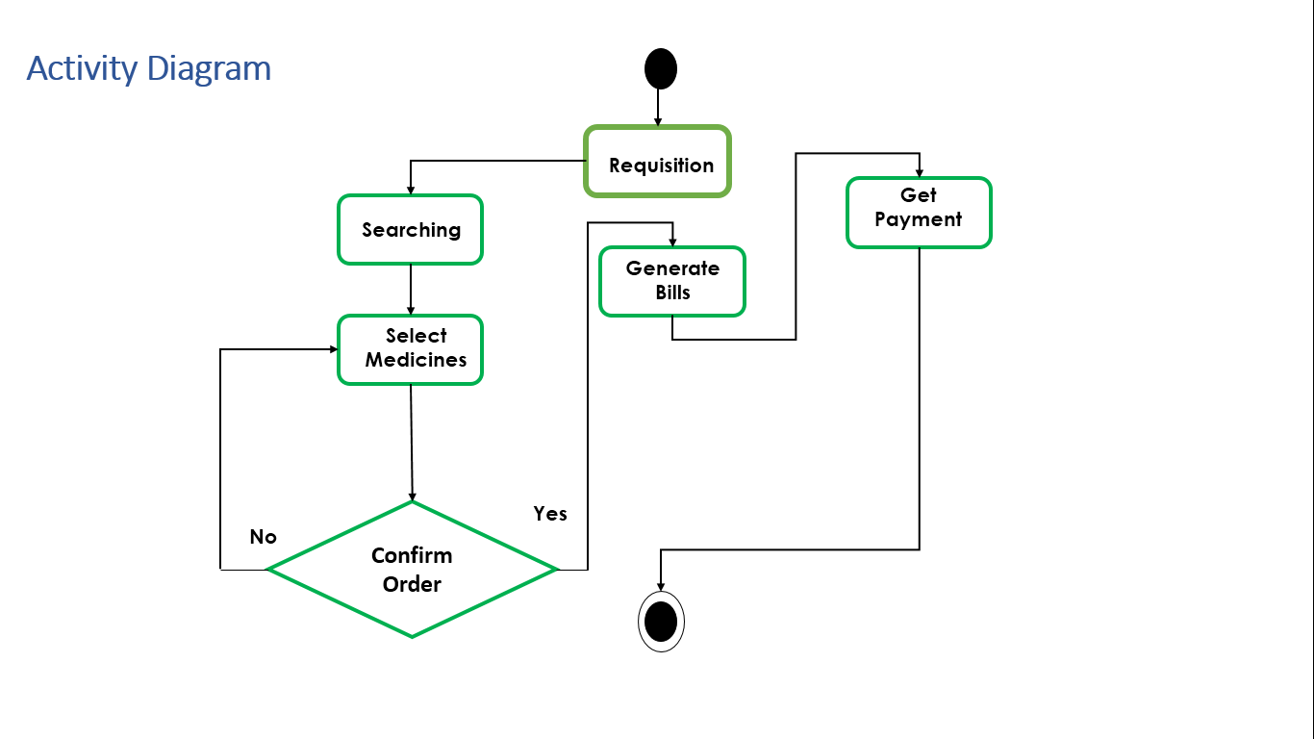

**3.2.5 Sequence Diagram**

**For Login:**



**Fig:** Sequence Diagram for Login

**For Customer Detail:**



**Fig.** Sequence Diagram for Customer Details

* + 1. **Class Diagram**

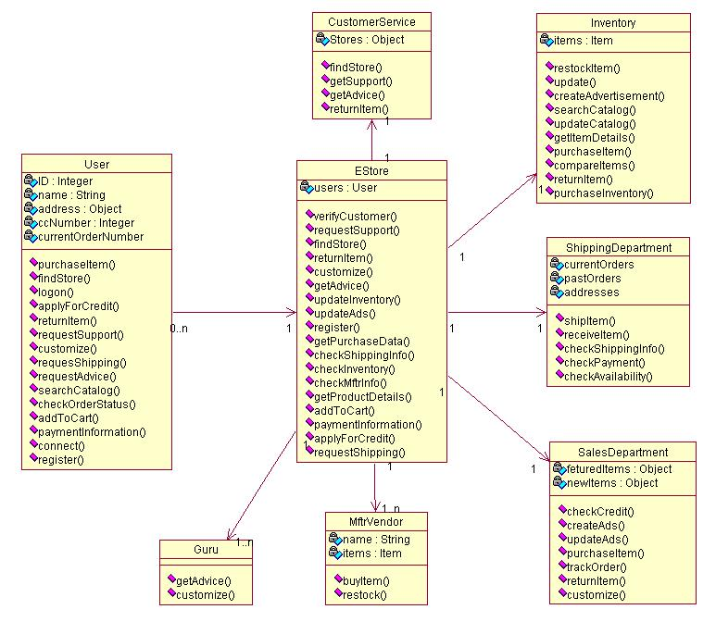

**Chapter 4**

**Conclusion Remark**

**CONCLUSION REMARK**

Generally, peoples have to go to the medical store for purchasing medicines. And medical store keeper manage the store manually. To overcome both the problems we want do develop a system which would provide the facility of Inventory Management System for Medical Store , by which customer can order the medicine online, and system can also be used as medical store management tool.

**Limitations of Project**

* This application is specially designed for medical shop, so can not be used anywhere else without modification.
* The code for the project is located at more than one location.
* No separate database for more than one Admin.
* It is a Desktop application not web application.
* In the condition of system failure the whole database may lose.
* The user can’t login if he forgets his username and password.

**Difficulties Encountered**

During the development of the project there were certain obstacles which we faced. Prominent ones being were:

* At first, the data flow diagrams were somehow difficult to implement.
* To implement reusable and efficient distributed application is a real difficult task.
* Limited knowledge of the language prevented us from giving a better interface.

**Future Enhancement and suggestions**

In future more functionality can be added to the system such as:

* A better graphical user interface can be provided.
* Can be implemented as web application
* On Web Application, customer car order their medicines online.
* Some more functionality can be added like feed back of customer.
* Separate database can b provided for multiple Admin.

**Chapter 5**

**References and Bibliography**

**BIBLIOGRAPHY AND REFERENCES**

**Reference Book**

* Head First Java 2nd Edition
* *Database Programming with JDBC and Java by O'Reilly*
* “The Complete Reference Java2”, Tata McGraw-Hill publishing Company Limited.

- Herbert Schildt.

* “Software Engineering, A Practitioner’s Approach”, Tata McGraw- Hill Publishing Company Limited.

- Roger S. Pressman.

* “PL/SQL”.

- Ivan Bayross.

**Other Documents and Resources**

* http://java.sun.com/javase/technologies/desktop/
* <http://google.co.in>
* <http://wikipedia.com>
* <http://www.java2s.com/>
* www.sun.com
* www.javaworld.com
* www.rational.com
* [www.ibm.com](http://www.ibm.com)
* www. medeil.com